ITCS254 | Lab 6: Processes | September 7, 2026
Name: QIMIN ZHU ID: 6888143_
Paste captured screenshots of the results for each question.

- List all process details, including PPID
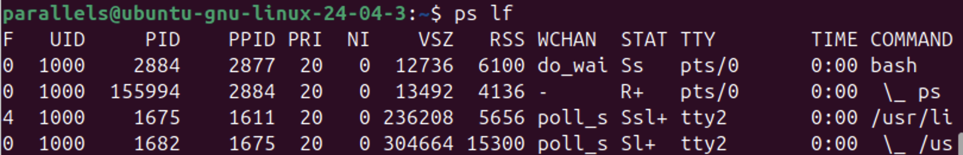

- Ascertain how long your system has been up. Display its load averages.

- In your machine environment, how many total running, sleeping, stopped, and zombie processes are there? Type answers below without a captured screen.

- Create a background process by running command “nano test1 &”, then list all processes to show that process, then kill that process.
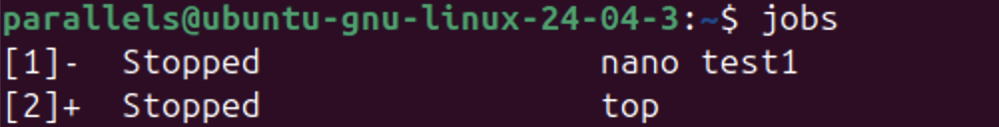
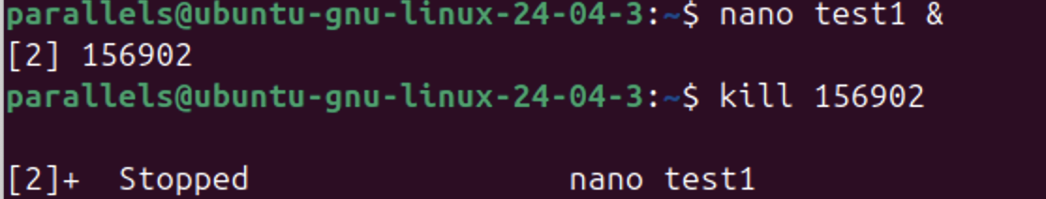

- Create a background process by running the command “nano test2 &”, then bring that process to the foreground process.
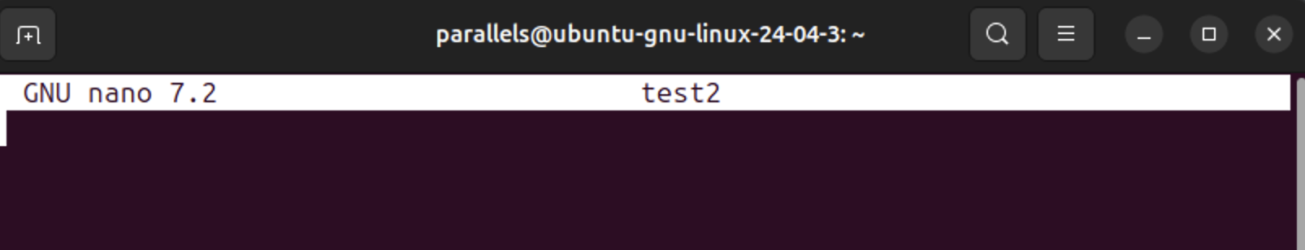

- Run the command “ps lf”, then change the nice value to be lower priority for the process of the command.
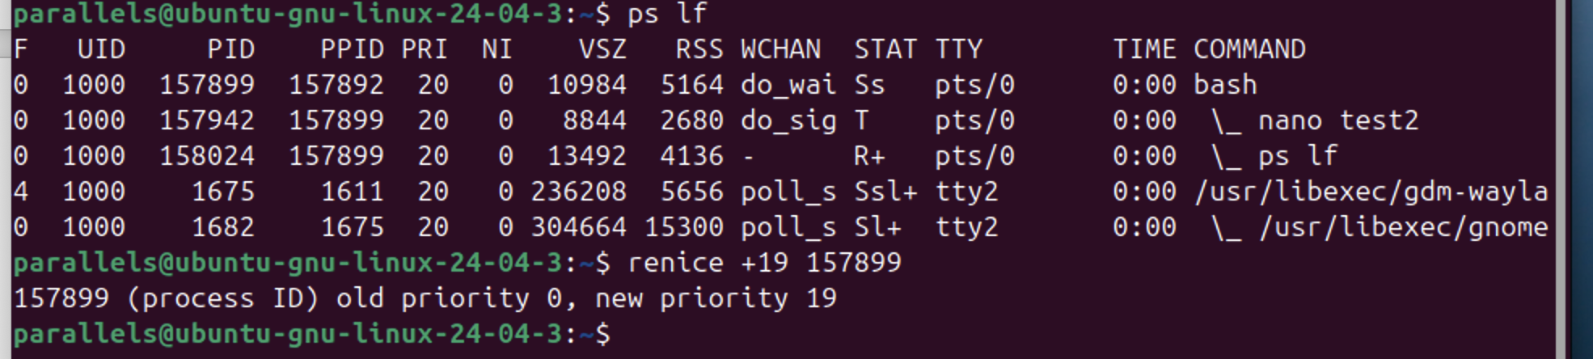

- Display all processes in real-time using top command ordered by the most used memory.
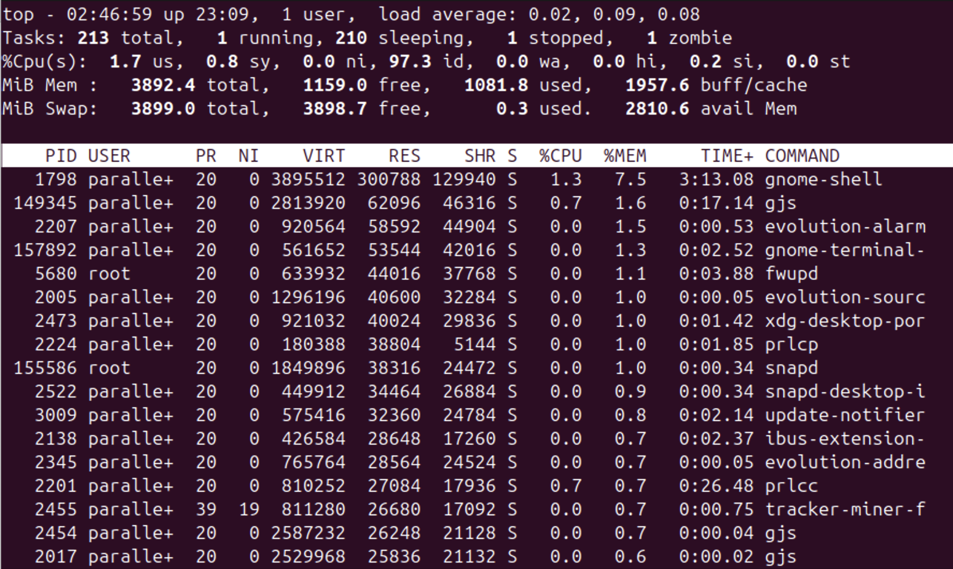

- How many total memory, used memory, free memory, and available memory in MB?
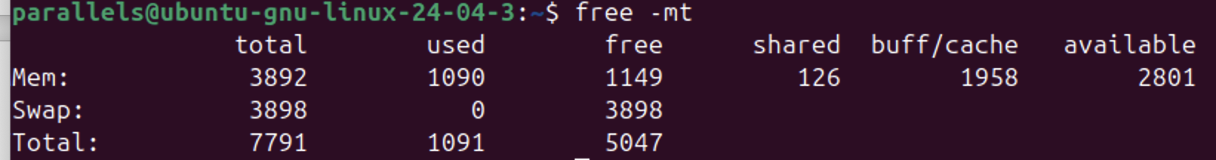

- Schedule to run this command in next 5 minutes: date > /tmp/datestamp
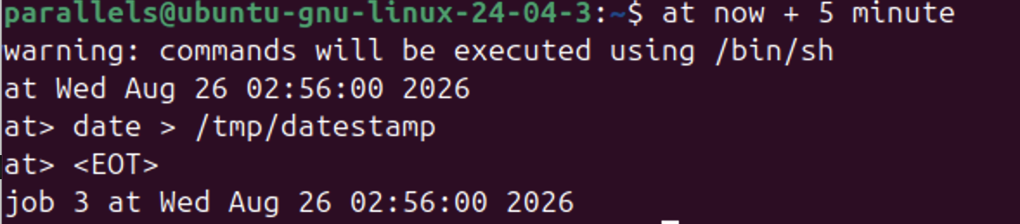
- Cronjob
  - Create a script file named myjob.sh containing following by run “nano myjob.sh”:
#!/bin/bash
echo Hello I am running $0 at $(date) > /tmp/hello-test
  - Make the above file executed by: chmod +x myjob.sh
  - Schedule the script to run in the next 5 minutes. Let’s note that you may need to check your time on the machine you’re using.
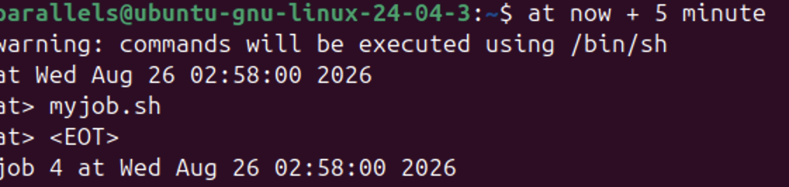
  - List scheduled jobs to make sure your job has been scheduled.
